Name: B.Vinayani
Registration Number: 192472179

EXPERIMENT 3
Zero-shot, One-shot and Few-shot Prompts - Summarize an Article in 50 Words

AIM
To design zero-shot, one-shot and few-shot prompts for summarizing an article into 50 words and to compare the generated summaries on accuracy, completeness and readability.

PROCEDURE
1. Open an LLM chat interface (such as ChatGPT, Gemini or Claude) in a new chat.
2. Zero-shot: enter an instruction that describes only the task (summarize the given article in 50 words) without any example, and note the response.
3. One-shot: start a new chat and enter the same instruction together with ONE worked example, followed by the actual task. Note the response.
4. Few-shot: start a new chat and enter the same instruction together with TWO worked examples, followed by the actual task. Note the response.
5. Capture a screenshot of each prompt with its generated output.
6. Compare the three outputs and record the observations.

PROMPTS (CODE)
Zero-shot prompt:
Summarize the following article in 50 words.

Article:
India's electric vehicle market is growing faster than many analysts expected. Sales of electric two-wheelers and three-wheelers have risen sharply over the past three years, helped by government incentives such as the FAME scheme and state-level subsidies on road tax and registration. Falling battery prices have also made electric models more affordable for first-time buyers. Major manufacturers, including Tata Motors, Mahindra and several start-ups, are launching new models and investing in local battery production to reduce dependence on imports.

However, the transition faces serious obstacles. Charging infrastructure remains limited outside large cities, and many apartment dwellers cannot install home chargers. Buyers also worry about driving range, battery life and resale value. In addition, most of India's electricity is still generated from coal, which reduces the environmental benefit of electric transport unless the grid becomes cleaner.

To overcome these barriers, the government has announced plans to expand public charging stations along highways and to encourage battery swapping, which lets drivers replace an empty battery within minutes. Experts believe that if charging networks improve and renewable energy capacity keeps growing, electric vehicles could account for a large share of new sales by 2030, cutting fuel imports and urban air pollution.

One-shot prompt:
Summarize the article in exactly 50 words, following the example.

Example article:
Remote work has become common since 2020. Employees save commuting time and report better flexibility, while companies reduce office costs. However, some workers feel isolated and managers struggle to measure productivity. Many firms now adopt a hybrid model, combining office days with remote days to balance collaboration and freedom.
Example summary:
Remote work offers flexibility and cost savings but brings isolation and productivity-tracking challenges. Many companies therefore prefer hybrid models that balance collaboration with freedom.

Article:
India's electric vehicle market is growing faster than many analysts expected. Sales of electric two-wheelers and three-wheelers have risen sharply over the past three years, helped by government incentives such as the FAME scheme and state-level subsidies on road tax and registration. Falling battery prices have also made electric models more affordable for first-time buyers. Major manufacturers, including Tata Motors, Mahindra and several start-ups, are launching new models and investing in local battery production to reduce dependence on imports.

However, the transition faces serious obstacles. Charging infrastructure remains limited outside large cities, and many apartment dwellers cannot install home chargers. Buyers also worry about driving range, battery life and resale value. In addition, most of India's electricity is still generated from coal, which reduces the environmental benefit of electric transport unless the grid becomes cleaner.

To overcome these barriers, the government has announced plans to expand public charging stations along highways and to encourage battery swapping, which lets drivers replace an empty battery within minutes. Experts believe that if charging networks improve and renewable energy capacity keeps growing, electric vehicles could account for a large share of new sales by 2030, cutting fuel imports and urban air pollution.
Summary:

Few-shot prompt:
Summarize the article in exactly 50 words, following the examples.

Example article 1:
Remote work has become common since 2020. Employees save commuting time and report better flexibility, while companies reduce office costs. However, some workers feel isolated and managers struggle to measure productivity. Many firms now adopt a hybrid model, combining office days with remote days to balance collaboration and freedom.
Summary 1:
Remote work offers flexibility and cost savings but brings isolation and productivity-tracking challenges. Many companies therefore prefer hybrid models that balance collaboration with freedom.

Example article 2:
Plastic pollution is choking oceans, harming marine life and entering the food chain. Governments are banning single-use plastics, while companies test biodegradable packaging. Experts say real progress needs better recycling systems and changes in consumer habits.
Summary 2:
Plastic pollution threatens oceans and food chains. Bans and biodegradable packaging help, but experts say stronger recycling and changed consumer habits are essential for real progress.

Article:
India's electric vehicle market is growing faster than many analysts expected. Sales of electric two-wheelers and three-wheelers have risen sharply over the past three years, helped by government incentives such as the FAME scheme and state-level subsidies on road tax and registration. Falling battery prices have also made electric models more affordable for first-time buyers. Major manufacturers, including Tata Motors, Mahindra and several start-ups, are launching new models and investing in local battery production to reduce dependence on imports.

However, the transition faces serious obstacles. Charging infrastructure remains limited outside large cities, and many apartment dwellers cannot install home chargers. Buyers also worry about driving range, battery life and resale value. In addition, most of India's electricity is still generated from coal, which reduces the environmental benefit of electric transport unless the grid becomes cleaner.

To overcome these barriers, the government has announced plans to expand public charging stations along highways and to encourage battery swapping, which lets drivers replace an empty battery within minutes. Experts believe that if charging networks improve and renewable energy capacity keeps growing, electric vehicles could account for a large share of new sales by 2030, cutting fuel imports and urban air pollution.
Summary:

OUTPUT
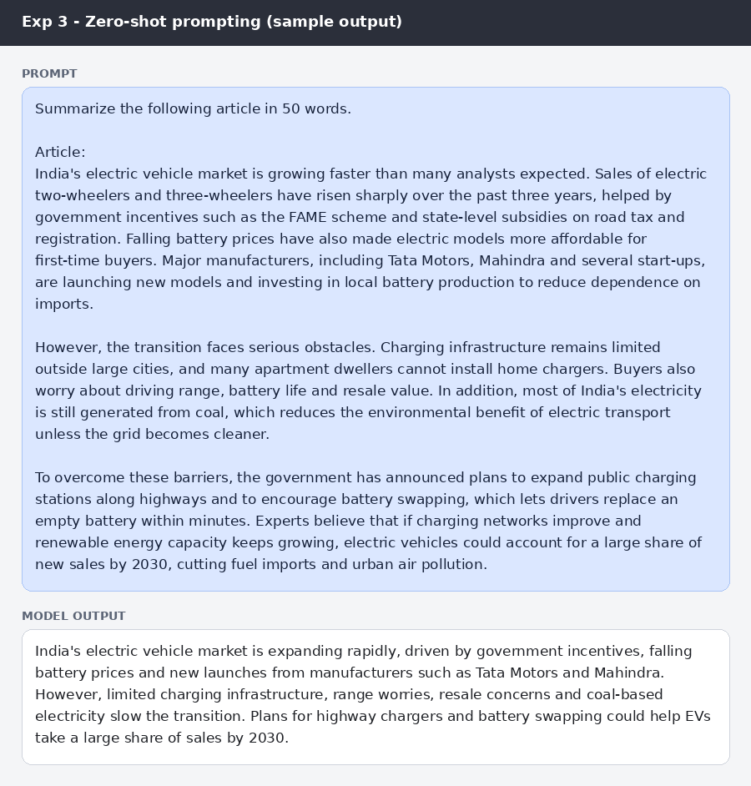
Figure: Zero-shot prompt and sample summary
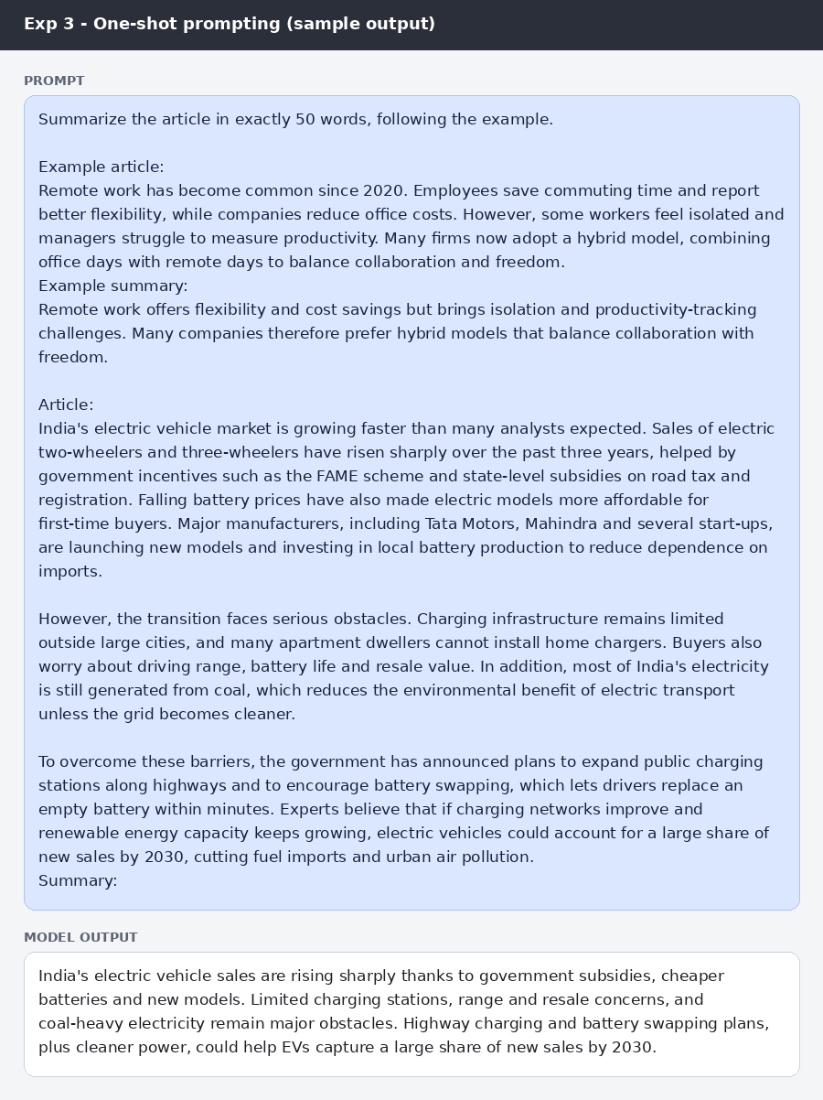
Figure: One-shot prompt and sample summary
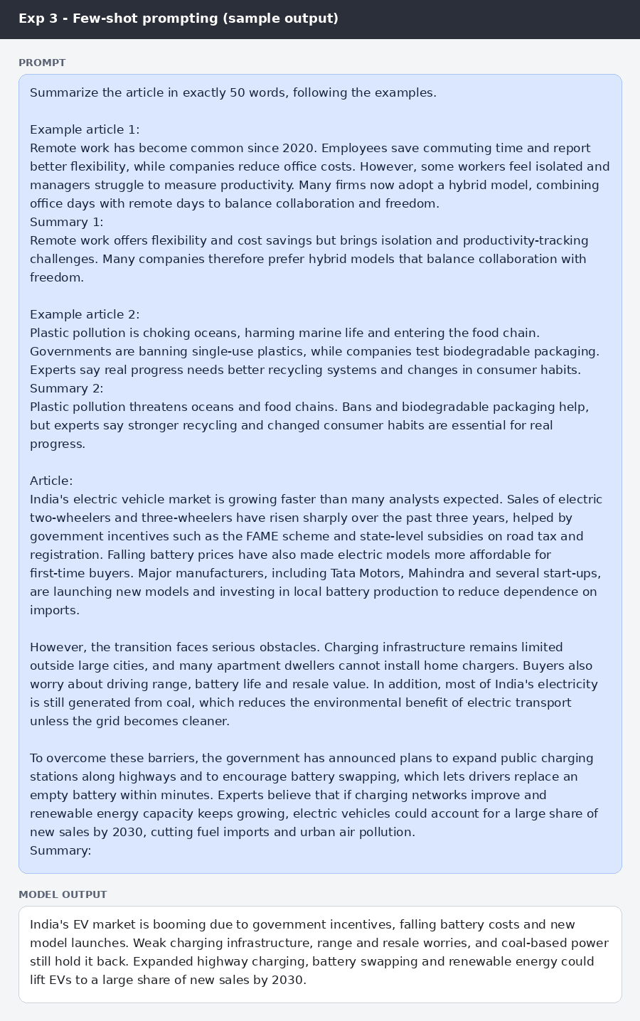
Figure: Few-shot prompt and sample summary
Comparison of the generated summaries
Criteria | Zero-shot | One-shot | Few-shot
Word limit (50) | 57 words - limit exceeded | 50 words - met | 50 words - met
Accuracy | All facts correct; nothing added from outside the article | All facts correct | All facts correct
Completeness | Most complete: growth drivers, named manufacturers, barriers, plans and the 2030 outlook | Covers drivers, barriers, plans and outlook; manufacturer names omitted | Covers drivers, barriers, solutions and outlook; manufacturer names omitted
Readability | Clear, but long sentences because of the extra length | Clear and smooth; balanced sentences | Most concise; short, direct sentences

RESULT
The zero-shot summary was accurate and the most complete but ran to 57 words, breaking the 50-word limit. The one-shot and few-shot summaries both met the 50-word limit exactly, stayed accurate, and kept the main points (growth, obstacles, government plans and the 2030 outlook). The few-shot summary was the most compact and readable, while all three were factually faithful to the article.

CONCLUSION
Examples help the model respect length constraints and write compactly. Zero-shot prompting favours completeness at the cost of length, whereas one-shot and few-shot prompting give accurate, readable summaries that meet the word limit, with few-shot being the most consistent.

